**F.E.T AGRA COLLEGE, AGRA**

**AFFILIATED TO**

**DR. A.P.J. ABDUL KALAM TECHNICAL UNIVERSITY,**

**U.P. (LUCKNOW)**



**Mini Project Report**

**On**

**“Smart Image Utility System”**

**SUBMITTED BY**

**Dheeraj Pal (2100020100035)**

**Lakshya Sharma (2100020100053)**

**Yogesh Kumar (2100020100117)**

**2nd year Computer Science and Engineering**

**SUBMITTED TO**

**Dr. Anuj Parashar**

**DEPARTMENT OF COMPUTER SCIENCE AND ENGINEERING**

**CONTENTS**

|  |  |
| --- | --- |
| SR. NO | CHAPTER NAME |
| 01. | ACKNOWLEDGEMENT |
| 02. | INRODUCTION |
| 03. | DEVELOMENT TOOLS |
| 04. | FEATURES |
| 05. | SNAPSHOTS |
| 06. | FUTURE SCOPE |
| 07. | LIMITATION |
| 08. | CONCLUSION |

**ACKNOWLEDGEMENT**

The completion of this project, the **Smart Image Utility System**, would not have been possible without the support and guidance of several individuals. We would like to express our sincere gratitude to the following people for their invaluable contributions:

* Our project guide **Dr. Anuj Parashar**, who provided us with invaluable technical support and guidance throughout the project.
* The **Department Of Computer Science And Engineering** at **Faculty of Engineering and Technology**, for providing us with the necessary resources and facilities to complete this project.
* Our classmates and peers, who have been a constant source of motivation and support.

We are deeply thankful to all of them for their support and for helping us to make this project a success.

**INTRODUCTION**

The Smart Image Utility System is a college mini project that aims to solve real-life problems related to image management. This system comprises of four utilities: Duplicate Image Deleter, Text Extractor, QR Code Scanner, and Image Compressor. Each utility addresses a specific issue in image management and provides a user-friendly solution. The Duplicate Image Deleter helps remove redundant images, the Text Extractor extracts text from images, the QR Code Scanner scans and decodes QR codes, and the Image Compressor reduces the size of images without sacrificing quality. This system is designed to simplify and streamline the process of image management for users.

**********************************

INTRODUCTION POINTS

**********************************

**DEVELOPMENT TOOLS:-**

We have made our Project with:

1. Language: Python.
2. We have used Sublime Text as our editor.
3. Modules we have used are : tkinter(for GUI),PIL/Pillow for image handling),pytesseract( for ocr reading),open-cv(for images),numpy(for handling multi-dimensional array),webbrowser(to open links),os(for operating system feautres)
4. Web-Browser: Google Chrome

**FEATURES:-**

* User friendly
* Portable
* Real life problem solving
* Easy to understand.
* JPG, PNG, jpeg type of file sharing support.

**SNAPSHOTS**

* **HOME PAGE**

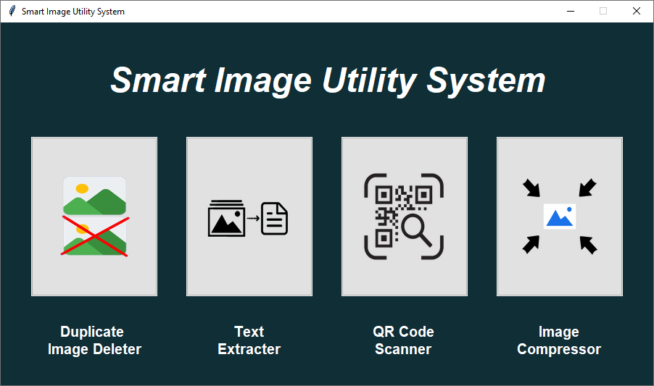

• SMART IMAGE UTILITY SYSTEM provides following features :

1. Duplicate Image Deleter

2. Text Extracter

3. QR Code Scanner

4. Image Compressor

* User can choose any of these features as per their requirement
* **DUPLICATE IMAGE DELETER**

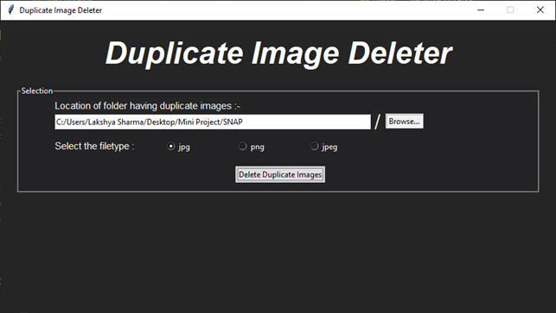

• The above window shows the Duplicate Image Deleter Utility.

•User can choose the folder having duplicate images either by entering its path into the entry box or by using browse button and can select the respective file type by the radio buttons.

•On clicking “Delete Duplicate Images” button the two possible outputs will be shown as follows:-

•The first window specifies that the duplicate images have been deleted.

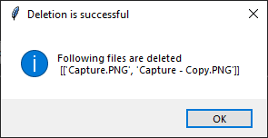

* The second window specifies that the given folder does not contains duplicate images.

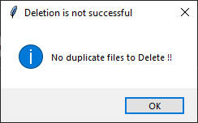

**Description:-**

1.This program converts every image to its grey scale image and then compare them with each other.

2.Images having similar gray scale are considered as duplicate images and then it keeps the original copy of image and deletes the other copies.

3.This program can delete duplicate files having “JPG”, “PNG” and “JPEG” extensions.

* **TEXT EXTRACTER**

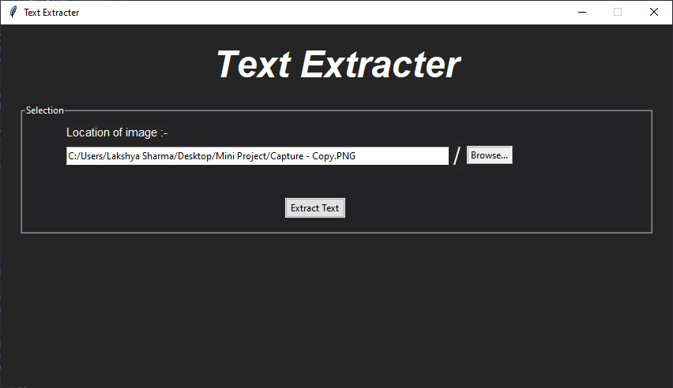

• The above window shows the Text Extracter Utility.

•User can choose the image having text either by entering its path into the entry box or by using browse button.

•After the desired path is entered in the entry box then click on “Extract Text” button.

•Extracted text will be shown into an editable text box.

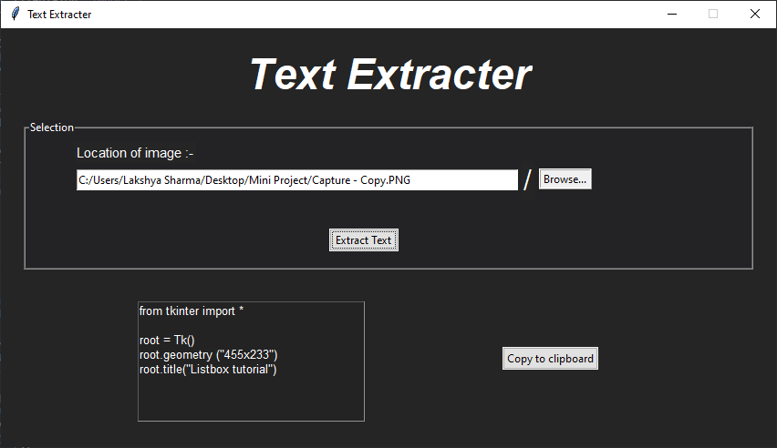

•User can copy the extracted text just by clicking on the “Copy To Clipboard” button.

* **QR CODE SCANNER**

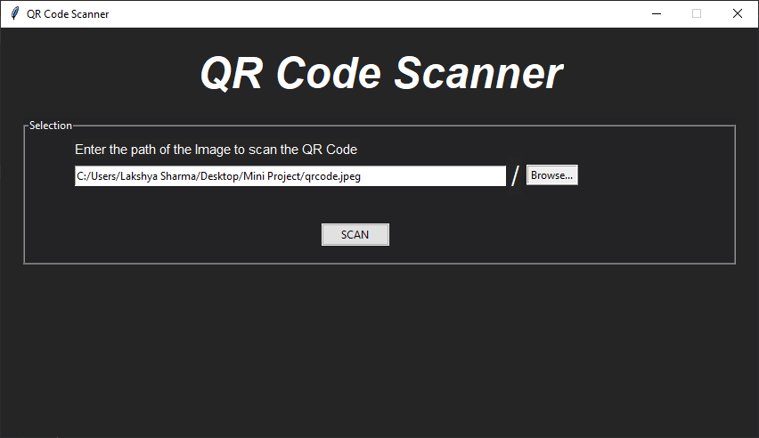

• The above window shows the Duplicate QR Code Sanner Utility.

•User can choose the QR code image either by entering its path into the entry box or by using browse button.

• After the desired path is entered in the entry box then click on “SCAN” button.

•Decoded Data will be shown into an editable text box.

•After the data is decoded from the QR code image user can either copy the data by clicking on the “Copy to clipboard ” button or can open it into the default internet browser. 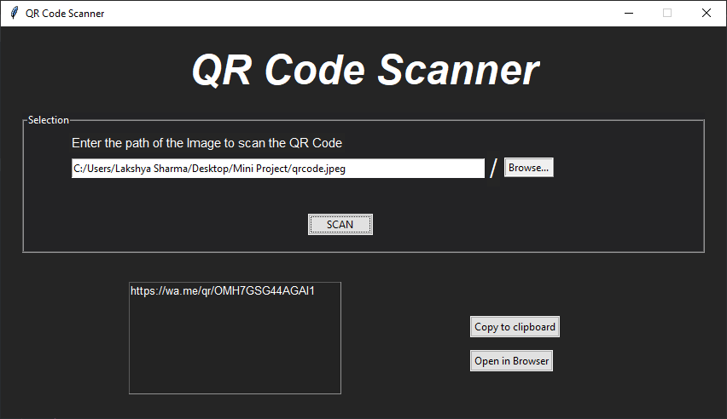 •Otherwise QR Code not detected message will be shown in a pop-up window.

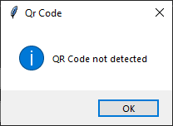

* **Image Compressor**

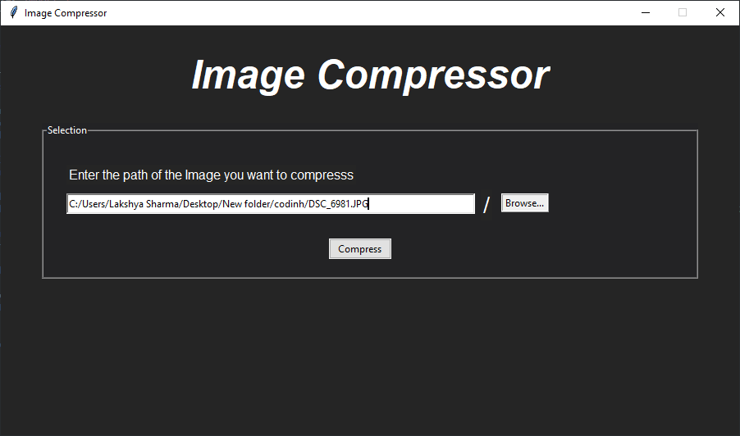

• The above window shows the Image Compressor Utility.

•User can choose the image that user want to compress either by entering its path into the entry box or by using browse button.

• After the desired path is entered in the entry box then click on “Compress” button.

•After the compression of image a pop-up message will be shown.

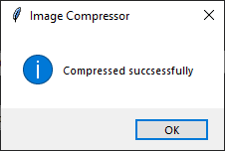

**FUTURE SCOPE**

* Big data Handling
* Artificial Image orientation correcter
* Extracting text from various languages.
* Classification of images using face recognition(A.I)
* On-Screen Text extraction.

**Limitation**

* Only jpg,png and jpeg files are accepted.
* Text extractor can only extract text from clear images.
* Text extractor cannot extract from other languages.
* Image can’t be compressed as per given size.

**CONCLUSION**

In conclusion, the Smart Image Utility System is a project that addresses real-life problems in image management. The four utilities - Duplicate Image Deleter, Text Extractor, QR Code Scanner, and Image Compressor - provide a user-friendly solution for various image management issues. The system's graphical user interface (GUI) makes image management simple and efficient for users. The project has demonstrated that it is possible to develop a comprehensive solution for image management using GUI-based tools. The results of this project have implications for further research in the area of image management, and provide a valuable contribution to the field.